|  |  |  |  |
| --- | --- | --- | --- |
| **TABLE OF CONTENTS** | | | |
|  |  |  |  |
|  |  |  |  |
| **CHAPTER** | **TITLE** |  | **PAGE** |
|  |  |  |  |
|  | Front Page | ------------------------------------------------- | i |
|  | Acknowledgement | ------------------------------------------------- | ii |
|  | Dedication | ------------------------------------------------- | iii |
|  | Abstract | ------------------------------------------------- | iv |
|  | Table of Contents | ------------------------------------------------- | v |
|  | List of Table | ------------------------------------------------- | vi |
|  | List of Figures | ------------------------------------------------- | vii |
| **I.** | **INTRODUCTION** | **-------------------------------------------------** | viii |
|  | 1.1 Project Context | **-------------------------------------------------** | ix |
|  | 1.2Purpose and Description | **-------------------------------------------------** | x |
|  | 1.3 Objectives of the Study | **-------------------------------------------------** | xi |
|  | 1.4 Scope and Limitation | **-------------------------------------------------** | xii |
|  | 1.5 Definition of Terms | **-------------------------------------------------** | xiii |
| **II.** | **REVIEW OF RELATED LITERATURE/SYSTEMS** | **-------------------------------------------------** | xiv |
|  | 2.1 Foreign and local related literature/ studies | **-------------------------------------------------** | xv |
|  | 2.2 Foreign and local related systems | **-------------------------------------------------** | xvi |
|  | 2.3 Table of comparisons | **-------------------------------------------------** | xvii |
|  | 2.4 Synthesis | **-------------------------------------------------** | xvii |
| **III**. | **TECHNICAL BACKGROUND** | **-------------------------------------------------** | xix |
|  | 3.1 Technicality of the project | **-------------------------------------------------** | xx |
|  | 3.2 Details of Technologies to be used | **-------------------------------------------------** | xxi |
|  | 3.3 How the project will work | **-------------------------------------------------** | xxii |
|  | 3.3.1 Functional Requirement | **-------------------------------------------------** | xxiii |
|  | 3.3.2 Non-Functional Requirement | **-------------------------------------------------** | xxiv |
| **IV.** | **METHODOLOGY, RESULT, DISCUSSION** | **-------------------------------------------------** | xxv |
|  | 4.1 Methodology | **-------------------------------------------------** | xxvi |
|  | 4.1.1 Agile methodology | **-------------------------------------------------** | xxvii |
|  | 4.1.1.1 Requirement and Analysis Phase | **-------------------------------------------------** | xxviii |
|  | 4.1.1.2 Design Phase | **-------------------------------------------------** |  |
|  | 4.1.1.3 Development Phase | **-------------------------------------------------** |  |
|  | 4.1.1.4 Testing Phase | **-------------------------------------------------** |  |
|  | 4.1.1.5 Deployment Phase | **-------------------------------------------------** |  |
|  | 4.1.1.6 Review Phase | **-------------------------------------------------** |  |
|  | 4.2 Result and Discussion | **-------------------------------------------------** |  |
|  | 4.2.1 Requirements and Analysis Phase | **-------------------------------------------------** |  |
|  | 4.2.2 Design Phase | **-------------------------------------------------** |  |
|  | 4.2.2.1 Use Case Analysis | **-------------------------------------------------** |  |
|  | 4.2.2.2 Context Diagram | **-------------------------------------------------** |  |
|  | 4.2.2.3 Data Flowchart Diagram | **-------------------------------------------------** |  |
|  | 4.2.2.4 Entity-Relationship Diagram | **-------------------------------------------------** |  |
|  | 4.2.2.5 Architecture Design | **-------------------------------------------------** |  |
|  | 4.2.3 Development Phase | **-------------------------------------------------** |  |
|  | 4.4.3.1 Gantt Chart | **-------------------------------------------------** |  |
|  | 4.4.3.2 Research/Capstone Project Team | **-------------------------------------------------** |  |
|  |  |  |  |
|  |  |  |  |
|  |  |  |  |

**ONLINE STUDENT CLEARANCE SYSTEM FOR THE INSTITUTE OF TECHNICAL EDUCATION ( ITE)**

An IT Capstone Project Proposal

Proposal presented to the Faculty of the

College of the Institute of Technical Education

Zamboanga Peninsula Polytechnic State University

In Partial Fulfillment of the Requirements

for the degree in Diploma of Technical Education Major in Information Technology

By

Jeryl B. Alalong

Gail S. Caluscusin

RJ B. Guibangguibang

Vanessa Mae O. Lamdagan

BELYN R. ENGUERRA, MEngg.Ed.

Adviser

FEBRUARY , 2025

**ACKNOWLEDGEMENT**

The proponents would like to express gratitude to our esteemed Capstone Adviser Professor **Belyn R. Enguerra, MEngg.Ed.**, for her invaluable guidance and insightful feedback throughout the process of our project.

Special appreciation is extended to the esteemed panel members, particularly **Mrs. Lobella D.P. Calago**, **Engr. Edgar L. Coronel MATVE**, and to our Chairperson professor **Neil Mark Z. Bacasong**, for contributing to the excitement, enjoyment, and memorability of our defense through their valuable feedback and suggestions. We express gratitude for the privilege of experiencing these remarkable moments.

Also, we would like to extend special thanks to our family, friends, classmates, and teachers for their constant encouragement, financial support, understanding, and patience during the challenging phases of this academic journey. Their love and support have been our anchor, motivating us to persevere.

Above all, we humbly extend our deepest gratitude to our almighty creator for the knowledge, strength, guidance and protection he lend us throughout the process of developing our capstone project and research. Also, for giving this opportunity that gave us so much to learn. It has been remarkable journey of ours.

**DEDICATION**

The proponents dedicate this Capstone Project to Almighty God whose grace and guidance have illuminated the path throughout this journey. We will always be forever grateful for your strength and wisdom.

To our parents, family, and relatives who stood by us during the challenges of this capstone project journey your love, support and sacrifices have made this journey possible.

To our friends, classmates, schoolmates, advisor, and mentor, who shared this journey with us, your camaraderie and support have made this experience unforgettable.

This Capstone Project also dedicated to my Professor Belyn R. Enguerra, MEngg.Ed. and Ms. Kristel Jane U. Panton Whose wisdom and guidance have inspired us throughout the research. Thank you for believing in the potential that we have in ourselves. To the future generations of students, may this work inspire you to pursue knowledge and innovation with passion and determination in your future endeavor.

**ABSTRACT**

Into day’s modern world, where technology is becoming a helpful tool for daily life. It simplifies our life by including a variety of information and tools. These days, technology notably enhances the learning environment in schools. So, the purpose of this capstone project is to replace the manual clearance process for students and staffs, it aims to develop the current system of the Institute of Technical Education (ITE) and come up with a system that helps students and staffs to create more effectively and reliable process of signing of clearance.

Each year, the Institute of Technical Education churn out number of students that must be cleared by different unit through a process called clearance. The traditional method of clearance involves student to physically visits clearance offices; student affairs, bursary, library, sports and registry department to get endorsed for clearance. The traditional method of clearance is time consuming, requires graduating student to physically visit various offices and some key staff may not be available at the time of visit and there is possibility of duplication or loss of data. Thus, the developed online clearance system overcomes the drawback to the traditional method of clearance. The online clearance system was developed using Windows 10 Operation System (OS) as development environment, MySQL for database design, Visual Studio Code (VsCode) for the overall programming and Hypertext Mark-up Language (HTML) couple with Cascading Style Sheet (CSS) for the Graphical User Interface (GUI).

**Keywords: Student Clearance, Online System, A Web-Based System, Agile Methodology Module**

**CHAPTER I**

**INTRODUCTION**

In the modern world, where technology is becoming a helpful tool for daily life. It simplifies our life by including a variety of information and tools. A web-based system offers an efficient platform for managing processes online, providing accessibility and convenience to users. In the context of an online student clearance system, it automates tasks such as grade evaluation, compliance tracking, and clearance approvals. This reduces manual work, streamlines operations, and minimizes the need for in-person interactions, ensuring a smoother and faster clearance process for both students and staff.(Santos et al., 2022)

The department of Institute of Technical Education (ITE) is a non board courses that offers 2-3 year program/courses; 3-year Diploma of Technology (DT), and a 2-year Trade Industrial Technical Education (TITE).These programs aim to produce competent graduates who can contribute effectively to their respective industries. Currently, the department relies on a manual process to determine whether students are eligible to proceed to the next semester. This process involves a school clearance system, where students' academic performance is reviewed to identify any difficulties in their subjects. The manual nature of this process requires frequent in-person interactions between students and instructors for completing and signing clearance forms, which is both time-consuming.

In this study, the proponents developed online student clearance, a systematic process of signing of clearance for students and teachers for easy access and a less hassle for students and teachers that queuing up students during clearance. The proposed capstone project, "Online Student Clearance System," features a comprehensive web-based system designed for the Institute of Technical Education (ITE).

* 1. **PROJECT CONTEXT**  
      The manual process of signing clearance forms at the Institute of Technical Education (ITE) has become a significant challenge, hindering accessibility and causing delays for both instructors and students. The current system is time-consuming and inefficient, requiring in-person interactions that limit the timeliness of the clearance process.

To address these challenges, the proponents proposed a project, titled "Online Student Clearance System," aims to improve the clearance process. By transitioning to an automated web-based system, the department will make the process faster, simpler, and more accessible for both faculty and students. This initiative is a crucial step towards creating a more effective and convenient system for managing student clearance at ITE.

**1.2 PURPOSE AND DESCRIPTION**

The purpose of this system is to develop an Online Student Clearance System that provides reliable, easy access and eliminates unnecessary waiting periods. The designed system will serve as a more efficient and effective means of managing student clearance, removing delays. Additionally, it will allow students to complete their clearance online with greater convenience.

In this regard, an online student clearance system has been designed and developed to automate the process of obtaining clearance from students and signing these clearances on the part of the academic institution. This ensures a smoother and more efficient process for both parties involved.

**1.3 OBJECTIVES OF THE STUDY**

**1.3.1 General Objectives**

The study aims to provide web system to enhance the manual process of clearance of the Institute of Technical Education (ITE) and to satisfy the needs of the user.

**1.3.2 Specific Objectives**

The specific objective of the study includes the following:

* To gather data in ensuring the system's requirements effectively process of Online Student Clearance System.
* To design and develop an efficient Online Student Clearance System to create a user-friendly interface for students and instructors.
* To test and evaluate the system for performance, security, and usability.

**1.4 SCOPE AND LIMITATIONS**

The proposed Online Student Clearance System is designed for use by both students and faculty at the Institute of Technical Education (ITE). This system will be implemented using a client-server model and will utilize Local Area Network (LAN) connectivity. It will focus on automating the web-based process for signing clearances, which will require internet access.

While the system is expected to improve efficiency, it may occasionally experience downtime or technical issues that could cause delays. By recognizing these potential challenges and implementing solutions, ITE can ensure that the online student clearance system delivers a smooth and effective experience for all users.

**1.5 DEFINITION OF TERMS**

**Clearance Status-** The current state of a student's clearance process, indicating whether they have met all academic and administrative requirements to proceed to the next semester.

**Css -** A language that describes the style and appearance of a web page.Css controls things like fonts, colors, layout, and responsiveness (how a website looks on different devices).

**Html** – The proponent used html for front end to lay out a documents general structure and content

.**JavaScript -** the proponent used this asa programming language that adds interactivity and dynamic behavior to web pages.

**Log-in/Log-out Services -** Secure access features that require authorized users (students, teachers, and administrators) to authenticate their identity before accessing the system.

**Online Student Clearance System-** A web-based platform designed to automate and streamline the process of obtaining and signing student clearances, reducing the need for physical presence and manual procedures.

**Registration** - Online registration for students is used to streamline and simplify the process of obtaining clearance from a school or institution.

**Student Module-** An account that students can create to log in and out of the system, load their subjects, and view their clearance status.

**Teacher Module-** An account that teachers can create to manage their subjects, view class lists, update student clearance statuses, and clear students clearances.

**Xampp-** is an open-source software package that allows users to test and develop web applications on their local computers. It's a local server that mimics a real web server.

**CHAPTER II**

**REVIEW RELATED LITERATURE/SYSTEM**

This chapter deals with the current study and the previous study, which is related to the proposed system. This study can assist the proponent rely on an example as a guide for the development of the system

**2.1 FOREIGN AND LOCAL RELATED LITERATURE/STUDIES**

**2.1.1.1 Web portal Applications: Automated Student Clearance Portal**

Web Portals Aplications: Automated Student Clearance Portal   
Francis E. Idachaba and K. claim that... The 2015 online portal by E. Mbeh, Oluwadamilola Oshin, and Oluyinka Oni is a website that unifies information from several sources. Each information source typically has a specific area on the page (a port let) for information presentation; frequently, the user can choose which sources to show. Web portals include features including email, news, stock prices, information and databases, and entertainment in addition to the typical search engine function. Web browsers proliferated in the late 1990s as a result of the increased use and penetration of Internet technology; businesses either created their own portals or purchased portals from other developers to participate.

**2.1.1.2 Development of Online Clearance System Using Web-Based System**  
 An internet-based system that efficiently maintains data for schools and universities is computer software, sometimes known as an online-based clearing system. The goal of this project is to replace the manual clearance process for graduating students with software for graduation services and follow-up. The technology eliminates any delays and makes it possible to comprehend the steps required and how to complete online clearing in a more dependable and efficient manner. The BUC collage provided the data, which was then utilized to create software that would be simple to use once graduates graduated. MYSQL was used to administer the database and Basic Visual 2015 was used for all static and dynamic programming in the online clearing system. The results show that the software is being used extensively.

(Abir AlSideiri, Ragad M Tawafak, Sohail Iqbal Malik, Ghaliya Alfarsi, Baidaa Hamza Khudayer, Roy Mathew, "Examining the Impact of Software Engineering Problem-Based Learning on Student Performance", *2023 24th International Arab Conference on Information Technology (ACIT)*, pp.1-6, 2023.)

**2.1.1.3 Development of Online Clearance System for an Educational Institution**

It is mandatory for graduating students of an educational institution to exit the system in an orderly manner. The students usually do this through the mandatory clearance process. The manual process is time-consuming and stressful as the students have to move from place to place to get their clearance document endorsed. It has also been found to be vulnerable to fraud and other vices. The few automated ones also exhibit some limitations in their functionalities such as non-user-friendly interface, lack of adequate information to user, non-prioritization of processes and so on. This study therefore proposes a system that overcomes the issues with manual processing while improving on the identified automated ones. The study adopts a case study approach of a complete manual system for a leading institution of learning in Southwest Nigeria, with a view to evolving a working prototype. First a thorough understanding of the existing procedure is carried out. A new system that is web-based is built using Hypertext Markup Language (HTML) along with PHP for business logic layer, CSS for proper rendering of display pages of the front end and MySQL for the data layer. The new system will reduce the amount of time and efforts wasted on students’ clearance as well as reduce cost incurred on paper by the institution. Another advantage is that students can also initiate and monitor their clearance status from any location they are thereby eliminating the need to travel or be physically present. ( It is according to these author; Oluranti Jonathan and Sanjay Misra and Funmilayo Makinde and Robertas Dama and Rytis Maskeliūnas and Marcelo, year 2019)

**2.2 FOREIGN AND LOCAL RELATED SYSTEM**

# 2.2.1 Student Clearance System (DLSU)

The Office of the University Registrar maintains the centralized student clearance system. To put a student “on hold,” a formal letter (signed by the office/unit head) must be submitted to the Office of the University Registrar, requesting a student(s) be “on hold.”

To clear a student, a formal letter (signed by the office/unit head) must be submitted to the Office of the University Registrar, requesting a student(s) be “cleared.” It is important to remember that a student put “on hold” remains as such until a request for clearance is received from the concerned office/unit.

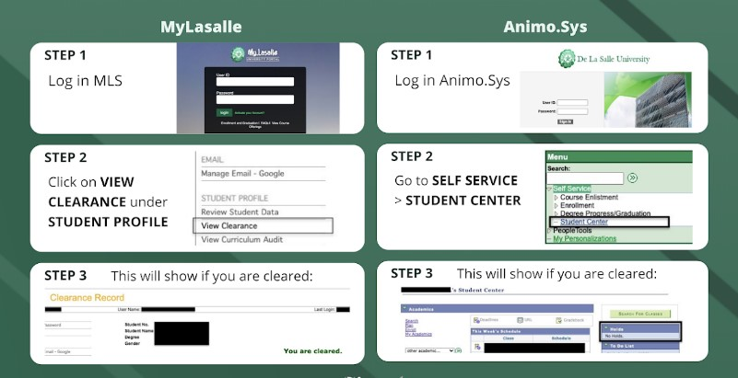

Figure 2.1 *Image/Screenshot of Student Clearance System (DLSU)*

**2.2.2 Moving Towards Global Technological Advancement: Basis for the E-Clearance Program Development**

Technology provides tremendous impact in the society gearing towards global advancement for schools, banks, hospital, and hotels. In school, college students used technology to everyday communication in Internet, Instant Messaging, Blogs and networking websites[1]. Thus, a web portal is designed for clearance to provide access by graduating students[2]. The online clearance will help ease the queuing of the school process [3] and can be an effective information management of the school [4]. A study by[5]stated that clearance is a certificate of disengaging students as a process of clearing the academic requirements. Exploring more the benefits of technological advancement, [6]encouraged colleges and universities to use a web-based system in recruitment, enrolment, communication, and assessment. The web-based tools were found to be of great help in meeting goals for recruitment, in streamlining the enrolment process, in communicating with potential students and families in real-time and in accelerating assessment process. Such technological advancement creates easier opportunities for everyone on campus to connect, share, ask, and work with one another. Currently, this school under study and many other schools in the country issue and process clearance manually. Paper clearance relies heavily on printing, which is costly. However, by using an automated system, paper printing is done away, reducing expenses. Other disadvantages of the manual system that a paperless system addresses are (1) costly, (2) time-consuming, and (3) stressful as one has to move from one office to the next and join a long queue.

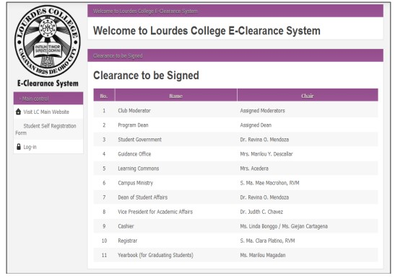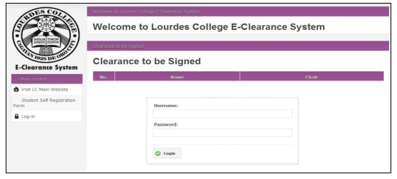

Figure 2.2 *Moving Towards Global Technological Advancement: Basis for the E-Clearance Program Development*

**2.2.3. Design and Implementation of Online Clearance System: A Case Study of Imo State University**

Online clearance system is an internet base research work that will help ease the queuing system in the university’s clearance process. Online clearance system will build an effective information management that is very convenient to use for schools since it is internet based and can be accessed from anywhere. It is aimed at developing a computer software system that replaces the manual method of clearance for graduating students and that also help students to carry out their clearance without coming to the various offices for clearance. The designed software will serve as a more reliable and effective means of undertaking students clearance, remove all forms of delay and stress as well as enable you to understand the procedure involved, as well as how to do your clearance online. This project work makes use of data collection from the university, materials and journals from various authors and the software was developed to effectively achieve the aim of the project. In this project, the implementation of the computer based system was carried out using PHP language, Html, CSS and the database for the software is MySQL. {Umezinwa Chukwuebuka Ben and Uwakwe Chikwado Henry and Abode Innocent Iriaoghuan, year 2015},

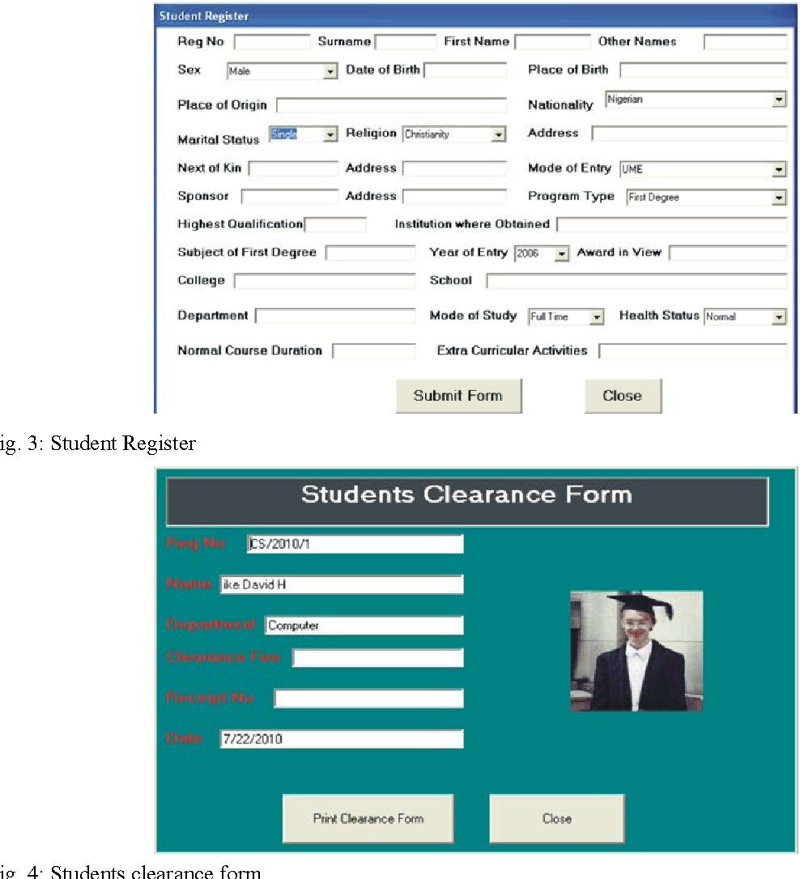*Figure 2.3 Image/screenshot of Student Clearnce of A Case Study of Imo State University*

**2.3 TABLE OF COMPARISON**

In the table below, all of the described systems are compared to the present proposed system.

|  |  |  |  |  |  |  |
| --- | --- | --- | --- | --- | --- | --- |
| Title | Create Account  (Students Only) | Registration/  Login/Logout | Print Clearnce  (Students Only) | View Clearance | Student Load Subject | Search Bar |
| **Online Student Clearance System for Institute of Technical Education (ITE)** | ✔ | ✔ | ✔ | ✔ | ✔ | ✔ |
| Student Clearance System (DLSU) | ✔ | ✔ | ✔ |  |  | ✔ |
| Moving Towards Global Technological Advancement: Basis for the E-Clearance Program Development | ✔ | ✔ |  |  |  | ✔ |
| Design and Implementation of Online Clearance System: A Case Study of Imo State University | ✔ | ✔ | ✔ |  |  |  |

**2.4 SYNTHESIS**

In summary, the synthesis of automated clearance systems in educational institutions reveals a common emphasis on leveraging web portals and advanced web-based technologies to streamline administrative processes, particularly student clearances. These systems integrate technologies like HTML, PHP, MySQL, and WAMP to enhance data management and user interaction, facilitating real-time updates and improving operational efficiency (Reyes & Santos, 2020; Development of Online Clearance System Using Web-Based System).

While each study aims to enhance efficiency and reliability by replacing manual methods with online systems, differences in scope and focus exist. Some studies highlight broad technological applications across educational settings, while others, such as the Student Clearance System at DLSU, focus on centralized clearance management and specific administrative procedures (DLSU Student Clearance System).

The proposed study aims to build upon these insights to develop a tailored Automated Clearance system for the School of Business Administration (SBA). By integrating technological advancements with institutional needs, the study seeks to improve administrative efficiency and user satisfaction within SBA, aligning with broader trends in educational technology.

In conclusion, automated clearance systems represent a significant advancement in educational administration, enhancing efficiency and user experience through innovative technological solutions tailored to institutional contexts.

**CHAPTER III**

**TECHNICAL BACKGROUND**

This section will delve into the technical aspects of developing an online student clearance system. The proponents have used web-based program wherein the users can access it through any digital platforms. The project’s design, technologies, and architecture have been conceptualized by the project’s proponents. However, the researchers will continue to improve, so the technologies described here are still subject to change.

**3.1 TCHNICALITIES OF THE PROJECT**

The proposed system is web-based where user can access the status of their clearance and admin or the instructor can easily clear students status of clearance without using the traditional method. Since the project is an IT-related study, there will be phrases and terminologies that only IT students and professionals can comprehend. The following terms uses in this system are HTML, CSS, PHP, Web Application, MySQL, Bootstrap, JavaScript,PhpMyAdmin, and Xampp.

**3.2 DETAILS OF TECHNOLOGIES TO BE USED**

The developers used bootstrap for the front-end User Interface design with the basic languages of HTML, CSS, and JavaScript. Draw.io software was used to create prototypes, graphics, and screen layout. For the back-end, developers used PHP as the main programming language and JavaScript as the secondary language. In addition, PhpMyAdmin was also used which is a free and open-source tool written in PHP intended to handle administration database with the use of web browser. The developer chose and used WampServer, a software stack for developing dynamic web applications.

**3.2.1 Software:**

**Frontend (User Interface):**

* + **HTML:** The foundation for web-pages, defining structure and content.
  + **CSS:** Controls visual appearance (fonts, colors, layouts).
  + **JavaScript:** Adds interactivity and dynamism (validation, data sending, UI updates).

**Backend (Server-Side):**

* + **PHP:** Processes user requests, interacts with the database, and generates dynamic content.
  + **MySQL Database:** Stores clearance information in tables (student data, clearance details, instructor info).
  + **Database Management Tool:** phpMyAdmin (for PHP) or MySQL Workbench for managing the database.

**3.2.2 Hardware:**

• Computer: This device was utilized by the proponents for coding and designing the system.

• Monitor: A component of computer hardware responsible for displaying video and

graphics information generated by a connected computer via its video card.

• Keyboard and mouse: The keyboard permits users to input letters and numbers, whereas

the mouse enables users to manipulate the pointer, draw, and execute program functions

through the clicking of mouse buttons.

**3.2.3 People ware:**

• Programmer (System Programmer, Application Programmer): Individuals responsible for

coding and designing the system.

• System Analyst: Individuals tasked with designing and analyzing.

• Project Manager: Individuals accountable for planning and organizing.

• Researchers: Collecting and analyzing data and sharing their findings

**3.2.4 Network**

• Web Hosting: The process of making the system available on the internet.

• Cloud Server: A centralized server resource accessible and managed over a network.

• Domain Host: An internet service provider responsible for managing your domain name.

• Wide Area Network (WAN): The technology linking various locations such as offices, data

centers, cloud applications, and cloud storage.

**3.3 HOW THE PROJECT WILL WORK**

The Online Student Clearance System will function as a web-based platform designed to streamline the clearance process for students and instructors within the School of Institute of Technical Education (ITE). The system will require students to create account wherein they will fill-in their full name, year level & section, semester if its 1st or 2nd, and student identification for them to have their own account and to get update on their clearance status. When they already got in, the provided Certificate of Registration (COR) given by the department is a testimony that you are enrolled for that particular semester and that COR contains subjects and instructors that are assigned. Student must load their subjects given to upon creating account. Also, granting them access to view the status of their clearances. They will be able to see whether their clearances have been cleared or remain uncleared by the instructors. On the other hand, instructors will have administrative access, allowing them to view subjects, students and clear the student clearances directly through the platform. They will also have the capability to input, delete and manage student information, including the subjects they are enrolled in and their clearance statuses. As well as the Administrator. The Admin has all the authority to manage the system’s overall work flow. Overall, this system will simplify the clearance process, making it more efficient and reliable for both students and instructors.

**3.3.1 Functional Requirements:**

**User Account Management:**

* Students can create accounts with their full name, year level & section, semester, and student ID.
* Instructors can be registered/created by the admin.
* Administrators can manage all user accounts (create, modify, delete).
* Users can log in and log out securely. Password reset functionality.

**Course/Subject Management:**

* Instructors can view the subjects they are assigned to.
* Administrators can add, edit, and delete subjects/courses.
* The system should link students to their enrolled subjects (from COR).

**Clearance Status Tracking:**

* Students can view the clearance status for each of their enrolled subjects.
* Instructors can mark student clearances as "Cleared" or "Uncleared" for their respective subjects.
* The system should display a clear overall clearance status for each student (e.g., "Cleared," "Pending," "Uncleared").

**Reporting:**

* The system should generate reports on student clearance status (for instructors and students)

A**dministrative Functions:**

* Administrators can manage instructors, students, subjects, and the overall system configuration.
* Administrators can generate reports on system usage and clearance trends.
* Audit trail: The system should log all actions performed by users, especially changes to clearance status.

**Data Management:**

* Secure storage of student, instructor, subject, and clearance data.
* Data backup and recovery mechanisms.

A**dministrative Functions:**

* Administrators can manage instructors, students, subjects, and the overall system configuration.
* Administrators can generate reports on system usage and clearance trends.
* Audit trail: The system should log all actions performed by users, especially changes to clearance status.

**Data Management:**

* Secure storage of student, instructor, subject, and clearance data.
* Data backup and recovery mechanisms.

**3.3.2 Non-functional requirements**

1. **Performance:**

* The system should be responsive and load quickly.
* The system should handle a large number of concurrent users without performance degradation.

2. **Security:**

* User authentication and authorization to protect sensitive data.
* Data encryption to prevent unauthorized access.
* Protection against common web vulnerabilities (e.g., SQL injection, cross-site scripting).

3. **Usability:**

* The system should be easy to use and navigate for both students and instructors.
* A clear and intuitive user interface.
* User-friendly instructions and help documentation.

4. **Availability:**

* The system should be available to users during specified hours (e.g., during the clearance period). High availability is desired.

5. **Scalability:**

* The system should be able to handle an increasing number of users and data as the school grows.

6. **Reliability:**

* The system should be reliable and free of errors.
* Data integrity should be maintained.

7. **Maintainability:**

* The system should be easy to maintain and update.
* Well-documented code and system architecture.

8. **Accessibility:**

* The system should be accessible to users with disabilities (e.g., following WCAG guidelines).

**CHAPTER IV**

**METHODOLOGY, RESULT, AND DISCUSSION**

This chapter focuses on presenting and explaining the methodology of developing Online Student Clearance. The developer will be utilizing the work plan, analysis strategies and the requirement documents.

**4.1 AGILE MODEL**

The Agile methodology is a project management approach that involves breaking the project into phases and emphasizes continuous collaboration and improvement. Teams follow a cycle of planning, executing, and evaluating.

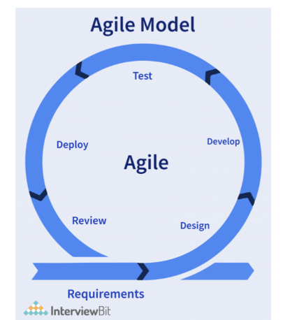*Figure 4. 1- Agile Model Extreme Programming*

**4.1.1.1 Requirement and Analysis Phase**

In this phase, the proponents collected and gathered all the necessary data and tools to ensure the successful development of the Online Student Clearance System. The goal of this capstone project is to replace the manual student clearance process with a web-based system, enhancing efficiency and eliminating long queues, thereby reducing students' waiting time. Additionally, it aims to help teachers and staff focus on more creative and productive tasks rather than being burdened with managing many students manually.

**4.1.1.2 Design Phase**

In this phase, students can clearly view their clearance status, grading performance, and personal information through the user interface (UI). The UI design ensures an intuitive and visually structured experience, making it easy to understand the system's workflow. Additionally, the system is responsive to mobile devices, providing a seamless experience across different screen sizes. A well-designed UI enhances usability and ensures user-friendly interaction with the system.

**4.1.1.3 Development Phase.**

In this phase, the development of the system requires both security and functionality to meet client expectations. The system design was developed in accordance with the client's qualification standards and successfully met all requirements. Additionally, secure coding practices were implemented to enhance security in both the backend and front end, ensuring a robust and reliable Application Programming Interface (API). Furthermore, a well-structured data infrastructure and optimized data structures were incorporated to improve system efficiency, scalability, and performance.

**4.1.1.4 Testing Phase**

Testing the system is a crucial step to ensure it is free from bugs and meets the client's functional requirements. The purpose of testing is to verify that the system operates correctly, securely, and efficiently according to the client's needs to achieve this, we implement Quality Assurance (QA) testing and penetration testing to evaluate the system's functionality, security, and reliability. These best practices ensure that the system is robust, reusable, and capable of handling real-world scenarios effectively.

**4.1.1.5 Deployment Phase**

In this phase, the production server is set up, and the system is deployed for users. This includes migrating necessary data from the existing system to ensure a smooth transition. The deployment process makes the system available to students and staff of the Institute of Technical Education (ITE) in a live environment or a local live environment, ensuring full functionality and accessibility.

**4.1.1.6 Review Phase**

In this phase, the proponents collected feedback on the developed system, identified potential errors, and addressed user concerns regarding functionality. Additionally, they continued improving and enhancing other system features.

**4.2 Results and Discussion**

This section presents and analyzes the findings based on the methodology used in the study.

**4.2.1 Requirements Elicitation Techniques**

The proponents utilized different data gathering techniques in conducting the capstone project. The proponents focused on surveying, observing, and brainstorming as requirement elicitation techniques and collaboratively researched the actual requirements for building the Online Student Clearance System. This serves as a guideline for building the proposed system and utilizing it effectively.

**4.2.2 Design Phase**

During the design phase, the proponents planned the system, chose the right tools, and made simple sketches. We decided how everything would work, kept users in mind, and improved the design before building it.

**4.2.2.1 USE CASE ANALYSIS**

The use case analysis established the system specifications, functionality, and the

**Online Subject Clearance System** focuses specifically on clearing students for their academic obligations, ensuring they meet subject requirements before progressing or graduating. The primary interaction involves teachers approving or rejecting students' clearance requests based on performance, attendance, or other academic criteria.

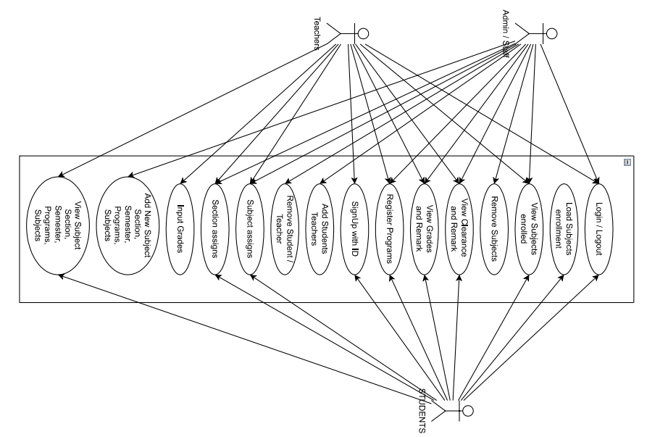

*Figure 4.2: Use case analysis*

In the Figure 4.2 it’s illustrates the interactions between system users’ admin/staff, Teachers, and Students and the Online Student Clearance System.

Admin/Staff manage user accounts, register programs, assign subjects and sections, oversee student enrollment, handle clearance and grading, and add or remove students and teachers. Teachers access student enrolled records, assign subjects, input grades, and provide clearance and academic remarks. Students log in to enroll in subjects, view academic records, check clearance and grading remarks, and remove subjects if necessary.

The system supports secure authentication, subject management, clearance tracking, and academic record updates, ensuring an efficient and structured clearance process at the Institute of Technical Education (ITE).

**4.2.2.2 CONTEXT DIAGRAM**



The context diagram depicts the interaction between the administrator, instructors, students, and the in and out data entry and output. The diagram can be useful in understanding the context in which the system will operate.



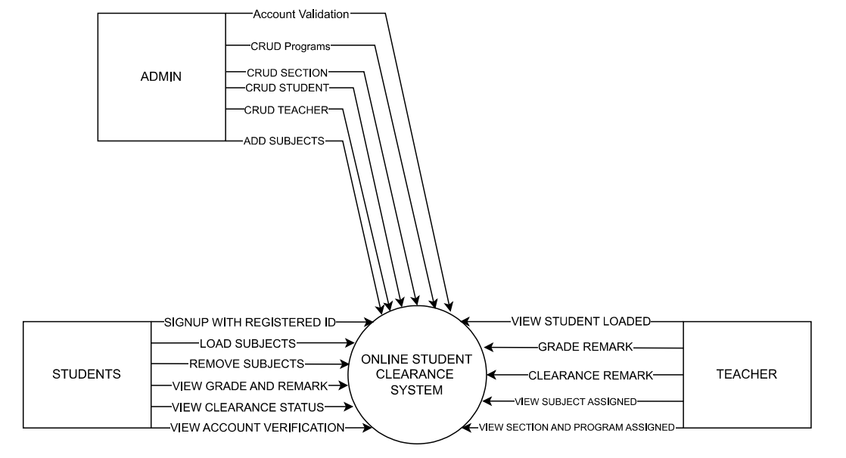

*Figure 4.3 Context diagrams*

In Figure 4.3, the diagram visually represents the system's context, helping stakeholders understand how different entities interact with the system. The admin manages account validation for both students and teachers and has authorized access to all system operations CRUD is a Create, Read, Update and Delete information on the system data. Teachers can view the students enrolled in their subjects. Students can have their subject loads by admin and can view their performance grades and clearance status, as marked by their subject teachers.

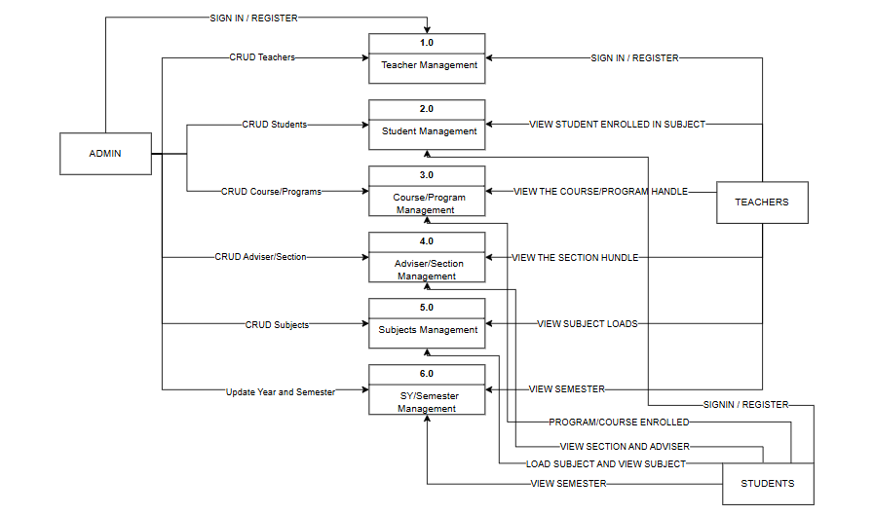**4.2.2.3 Data Flow Diagram Level 0**

*Figure 4.4 Data Flow Diagram Level 0*

The Data Flow Diagram (DFD) Level 0 represents the flow of information within the system, including teacher management, student management, course/program details, subjects, and sections. It illustrates how teachers and students interact with the system, their account management, and their access to various system features.

**4.2.2.4 Data Flow Diagram Level 1 of Process 1and 3**

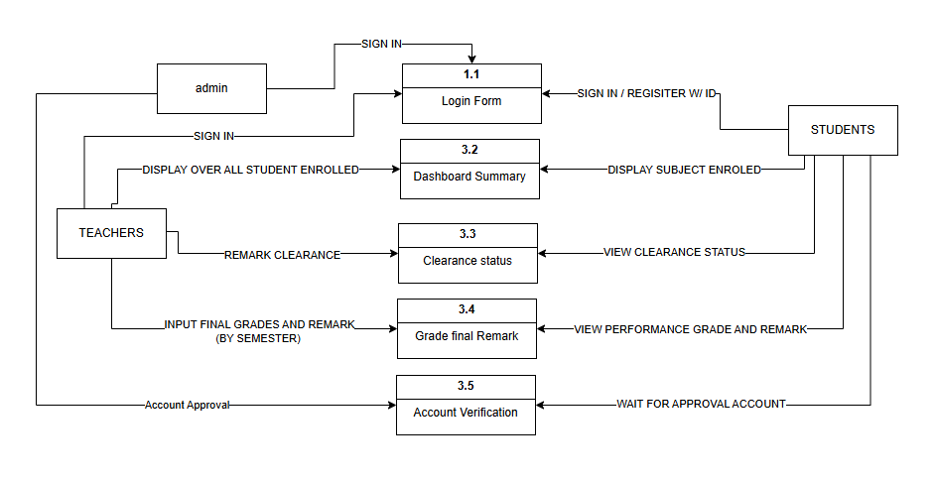

*Figure 4.5 Data Flow Diagram Level 1 of Process 1and 3*

The Data Flow Diagram (DFD) Level 1 of Process 1 and Process 3 illustrates how the admin, teacher, and student interact within the clearance process. It depicts the flow of information, including how students submit clearance requests, how teachers input final grades, and how administrators review and approve accounts.

**4.2.2.5 FLOW CHART DIAGRAM**

The flow diagram depicts the information of the admin, teacher, and students in the important functions, such as creating accounts, login, load subjects, and clearance process.

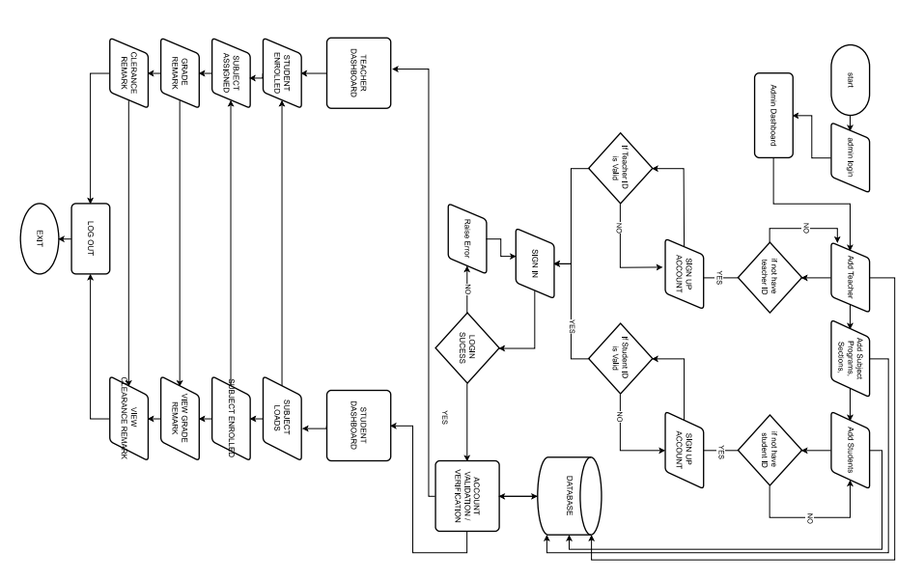

*Figure 4.4 Flowchart Diagrams*

In the (Figure 4.4) Flow Chart Diagram it provides a visual representation of the system’s data flow, ensuring that all essential processes are systematically structured for efficient data management and accessibility. Admins manage user accounts, validate Teacher and Student IDs, and oversee database storage. Teachers access their dashboard to view enrolled students, assign subjects, provide grade remarks, and update clearance status. Students log in to view subject loads, enroll in subjects, check grades, and monitor clearance status. The system enforces strict account validation, allowing only authorized users to sign up and preventing unauthorized access. Secure session management ensures proper user logout to maintain data security. This structured data flow optimizes the clearance process, enhancing efficiency, security, and accessibility within the Institute of Technical Education (ITE).

**4.2.2.6 ENTITY-RELATIONSHIP DIAGRAM (ERD)**

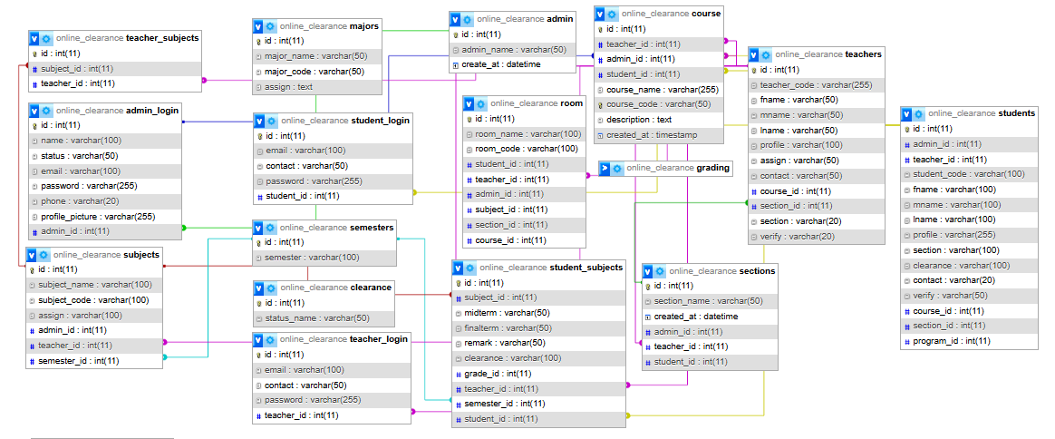The Online Student Clearance System is a web-based system, and it can use applications to help students view their clearance status.

*Figure 4.5 ER Diagrams*

In the diagram (Figure 4.5) illustrates how data is designed with a structured data management approach, ensuring seamless operations and secure data handling. The system efficiently manages student records, linking them to teachers, subjects, grading, and clearance status. Teachers are associated with assigned subjects and sections, while administrators oversee user accounts, clearance processes, and data security.

Key functionalities include secure authentication, role-based access control, and structured academic management. The system tracks student clearance requests, manages grading records, and organizes students by sections and semesters. Additionally, classroom assignments help facilitate academic scheduling

By maintaining well-defined relationships between entities, the system ensures data consistency, security, and efficiency, improving the clearance process for students, teachers, and administrators at the Institute of Technical Education (ITE).

**4.2.2.7 ARCHITECTURE DESIGN**

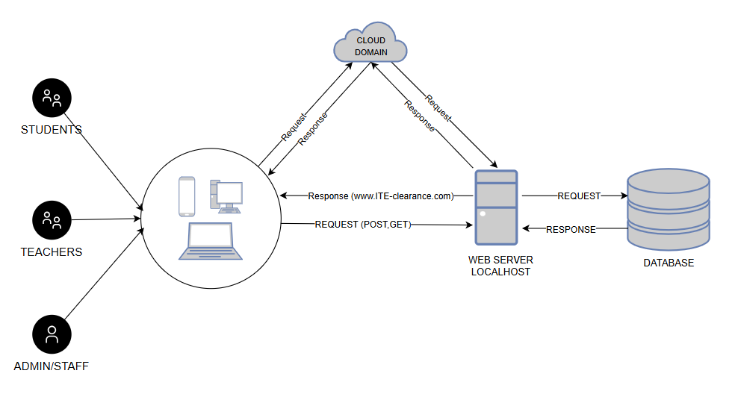 Architecture design serves as the design process covered within the system to be developed. The system will operate through a web based.

*Figure 4.6 Architecture Design*

In the diagram (Figure 4.6) illustrates how server network configuration the data from the cloud domain and defines the interaction between users, the web server, the database, and the cloud domain. Students, Teachers, and Admin/Staff access the system using various devices, sending requests via POST and GET methods to the local web server. The web server processes these requests, retrieves or updates data from the database, and responds accordingly. Additionally, the system integrates with a cloud domain, allowing external access through [www.ITE-clearance.com](http://www.ITE-clearance.com) by forwarding requests and receiving responses. This architecture ensures efficient data processing, secure communication, and seamless accessibility for all users.

**4.2.3** **DEVELOPMENT PHASE**

The development of the Online Student Clearance System started with gathering requirements from the dean of Institute of Technical Education (ITE) which is our client. The team designed the system's layout, database, and user interface based on the collected information. After planning, proponents wrote the code and built the system features, such as student creates accounts, load subjects, teacher makes clear/unclear students’ clearance, and progress tracking. Testing was done to find and fix errors, ensuring smooth performance.

Once testing was completed, the system was deployed for use. Training was provided for students and staff to help them understand the system. Feedback was gathered, and improvements were made to enhance functionality. Finally, the project was completed, and the system was fully implemented for clearance processing.

**4.4.3.1 GANTT CHART**

The Gantt chart served as the timeline and schedule for the project’s development. The team followed the stages of the Agile Methodology, as shown above. Each phase was important in reaching the project goals and delivering the expected results.

Table 4.1: Gantt chart - Title Defense

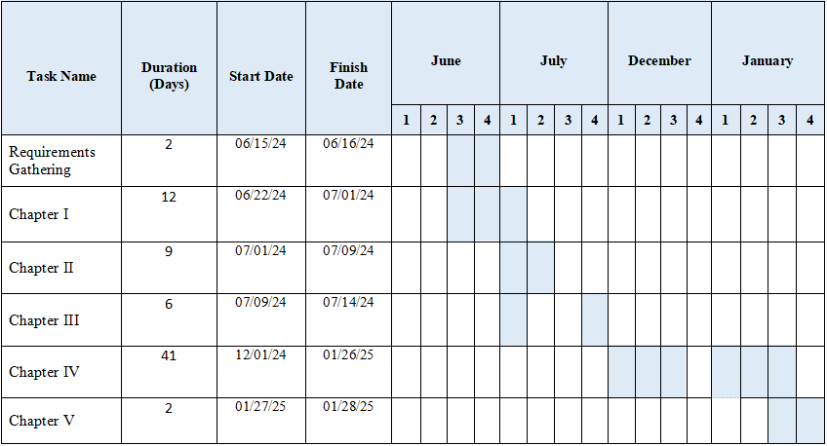

**4.4.3.2 RESEARCH/CAPSTONE PROJECT TEAM**

This section described the tasks assigned to each team member. The team included programmers, testers, project managers, data analysts, and documentation specialists.

Table 4.2: Project Work plan

|  |  |  |  |  |  |
| --- | --- | --- | --- | --- | --- |
|  | | | Estimate | | |
| Task ID | Task Description | Assigned | Duration (Days) | Start Date | End Date |
|  | Requirements Gathering | Proponents | 2 | 06/15/24 | 06/16/24 |
| **I** | Chapter I: Introduction | Gail Caluscusin | 2 | 06/22/24 | 06/23/23 |
| **1.1** | Project Context | Gail Caluscusin | 2 | 06/24/24 | 06/25/24 |
| **1.2** | Purpose & Description | RJ Guibangguibang | 2 | 06/26/24 | 06/27/24 |
| **1.3** | Objectives of the Study | Jeryl Alalong | 2 | 06/27/24 | 06/28/24 |
| **1.4** | Scope and Limitation | RJ Guibangguibang | 2 | 06/29/24 | 06/30/24 |
| **1.5** | Definition of Terms | RJ Guibangguibang | 2 | 06/30/24 | 07/01/24 |
| **II** | Chapter 2: Review  Related Literature/Systems | All members | 1 | 07/01/24 | 07/01/24 |
| **2.1** | Foreign and Local related literature/studies | Gail Caluscusin  Vanessa Lamdagan | 2 | 07/02/24 | 07/03/24 |
| **2.2** | Foreign and local related Systems | Jeryl Alalong  RJ Guibangguibang | 2 | 07/04/24 | 07/05/25 |
| **2.3** | Table of comparisons | Gail Caluscusin | 2 | 07/06/24 | 07/07/24 |
| **2.4** | Synthesis | RJ Guibangguibang | 2 | 07/08/24 | 07/09/24 |
| **III** | Technical Background | All members | 3 | 07/09/24 | 07/11/24 |
| **3.1** | Technicalities of the project | Gail Caluscusin  Vanessa Lamdagan | 1 | 07/13/24 | 07/13/24 |
| **3.2** | Details of the technologies to be used | Jeryl Alalong  RJ Guibangguibang | 1 | 07/14/24 | 07/14/24 |
| **3.3.** | How the project will work | Gail Caluscusin  Jeryl Alalong | 1 | 07/14/24 | 07/14/24 |
| Table 4.2 Continuation | | | | | |
| **IV** | Chapter 4: Methodology, Result and Discussion | Gail Caluscusin  Jeryl Alalong | 3 | 12/01/24 | 12/03/24 |
| **4.1** | Methodology | Gail Caluscusin | 5 | 12/16/24 | 12/20/24 |
| **4.2** | Result and Dicussion | Gail Caluscusin | 10 | 12/20/24 | 12/30/24 |
| **4.3** | Usability Testing | RJ Guibangguibang | 4 | 01/03/25 | 01/06/25 |
|  | Use Case Analysis | Jeryl Alalong | 1 | 01/08/25 | 01/08/25 |
|  | Data Flowchart Diagram | Jeryl Alalong | 1 | 01/09/25 | 01/09/25 |
|  | Entity-Relationship Diagram | Jeryl Alalong | 1 | 01/10/25 | 01/10/25 |
|  | Architecture Design | Jeryl Alalong  Gail Caluscusin | 1 | 01/11/25 | 01/11/25 |
|  | Use case testing | Jeryl Alalong  RJ Guibangguibang | 2 | 01/12/25 | 01/13/25 |
| **4.3** | Usability Testing | Jeryl Alalong  RJ Guibangguiban | 2 | 01/14/25/ | 01/15/25 |
| **4.4** | Deployment and Feedback | Jeryl Alalong  Gail Caluscusin  RJ Guibangguibang | 4 | 01/16/25 | 01/19/25 |
| **4.4.3** | Gantt Chart | Gail Caluscusin | 1 | 01/20/25 | 01/20/25 |
| **4.4.4** | Research/Capstone project teamwork | Gail Caluscusin | 1 | 01/21/25 | 01/21/25 |
| **4.5** | Description Prototype | Jeryl Alalong  Gail Caluscusin | 5 | 01/22/25 | 01/26/25 |
| **V** | Chapter V: Conclusion and Recommendation | Vanessa Lamdagan | 2 | 01/27/25 | 01/28/25 |

Table 4.3 Project Team Role

|  |  |
| --- | --- |
| **Task** | **Title Project** |
|  | Online Student Clearance System for Institute of Technical Education |
| **PROJECT MANAGER** | **ASSIGNED PERSON** |
| DATA ANALYST | Jeryl Alalong |
| DATA GATHERING | Vanessa Lamdagan |
| DOCUMENTATION | Gail Caluscusin |
| PROGRAMMING | RJ Guibangguibang |
| TESTING | Jeryl Alalong |

**4.6 Analysis Phase (Preparation and Draft Documentation)**

In this phase, the developers focused on creating a document using Requirement Elicitation techniques applied before brainstorming and surveying. Additionally, the proponents worked overnight to complete the documentation

**4.7 Programming Phase (Design, Coding and Development)**

Mr. RJ Guibangguibang is a software engineer who focused on system development and alongside other team members, contributed to debugging and researching the functions of this project.

**4.8 Unit Testing**

The unit testing of the project is done by the proponents upon successfully developing the project, to ensure that everything was operating as intended. The programmer conducted unit tests on all of the project's modules and functions in front of the respondents. The purpose of unit testing phase was to ensure that the system was operating effectively.

**4.2.3.1** **IMPLEMENTATION PHASE**

In the implementation of the system, we use a simple linear formula to evaluate the system's performance. The formula helps measure accuracy, request-response time, system uptime, and scalability over a 24-hour period.

The system allows admins and teachers to add and display results efficiently. Using this formula, we can analyze the following below the Accuracy, Response Time, Uptime and availability, and scalability.

4.2.3.1.1 **Reliability Formula**

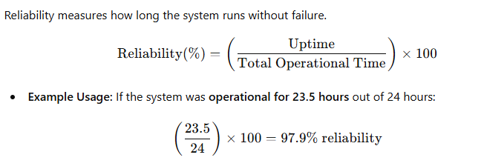

4.2.3.1.2 **System Throughput**

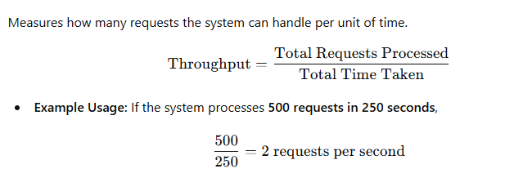

4.2.3.1.3 **Error Rate Formula**

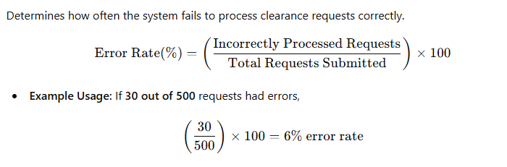

4.2.3.1.4 **User Satisfaction Index**

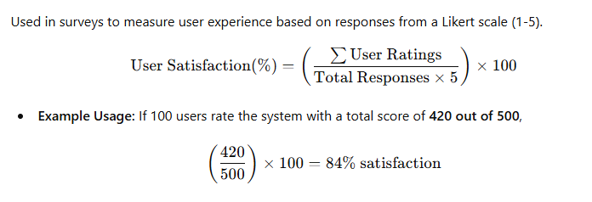

4.2.3.1.5 **Response Time Formula**

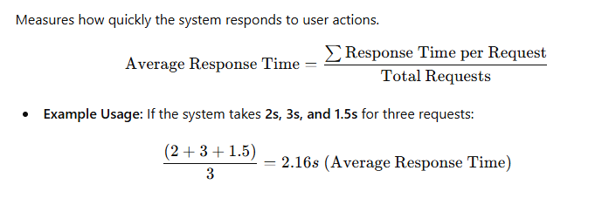

4.2.3.1.6 **System Accuracy Formula**

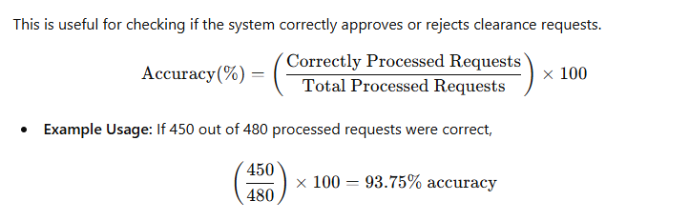

4.2.3.1.7 **System Efficiency Formula**

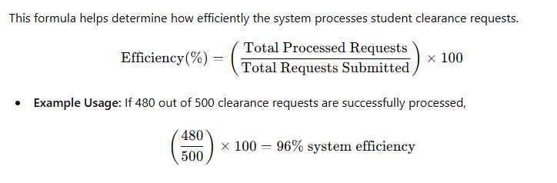

**4.2.4 TESTING PHASE**

The system analyst, front-end designer, and programmer collaborate to test the functionality, usability, and reliability of the system. This phase ensures that all system components work properly, meet the specified requirements, and provide seamless user experience. Functionality is to ensure all system features work as intended,

Usability is to check the user interface (UI) for an intuitive and accessible design.

Performance refers to evaluating the system speed, response time, and efficiency

Security is to identify vulnerabilities and ensuring data protection and the

scalability is to test how well the system handles multiple users and requests.

**4.2.5 TESTING PLAN**

The main goal of the testing plan is to ensure the input validation of the student sign-up process and the accuracy of clearance status updates by teachers and administrators. This phase evaluates the system’s functionality, ensuring that student accounts are properly registered and that clearance requests are processed correctly.

**4.2.6 OBJECTIVES OF TESTING PLAN**

The primary objective of the testing plan is to ensure that the Online Student Clearance System functions accurately, efficiently, and securely before deployment. To achieve this, the system must be protected against Cross-Site Scripting (XSS), vulnerabilities, and exploitation, while implementing data encryption to safeguard sensitive student information. Additionally, unauthorized access and modifications to student grades and personal data must be prevented to maintain data integrity and confidentiality. Ensuring the accuracy of student records is crucial, preventing any unauthorized alterations, data breaches, or the unintended spread of student information. Furthermore, system functionality and performance will be validated by confirming that the clearance request and approval processes operate correctly, while also ensuring fast response times and stability under various workloads. By accomplishing these objectives, the system will be secure, reliable, and capable of managing sensitive student data, preventing unauthorized access or modifications while maintaining overall system efficiency.

**4.2.7 SCOPE OF TESTING**

The scope of testing defines the specific areas covered during the evaluation of the Online Student Clearance System to ensure it meets all functional, security, and performance requirements. This testing process will focus on key system components, including student registration, login authentication, clearance request submission, faculty and admin approval processes, and system-generated reports. Additionally, usability, security, and performance will be assessed to ensure a seamless user experience. Testing will also cover data integrity, scalability, and responsiveness, verifying that the system can handle multiple concurrent users efficiently while maintaining accuracy and security.

**4.2.8 TEST CASE RESULT OF THE ONLINE STUDENT CLEARANCE SYSTEM**

The test case results provide a detailed analysis of how the system performs under different testing scenarios. Each test case is designed to evaluate a specific function, such as user authentication, clearance request approval, database management, and security protocols. The results will determine whether the system behaves as expected or if modifications are needed. If any issues arise, necessary refinements will be made before deployment to ensure the system is fully operational and meets all user requirements.

|  |  |  |  |  |
| --- | --- | --- | --- | --- |
| Test case id | Test description | Expected result | Actual result | Status |
| TC001 | Student login with valid credentials | Successful login | Successful login | ✅ Passed |
| TC002 | Login with incorrect credentials | Error message displayed | Error message displayed | ✅ Passed |
| TC003 | Submit clearance request | Request saved in the database | Request saved in the database | ✅ Passed |
| TC004 | Faculty approves/rejects clearance request | Status updated in system | Status updated in system | ✅ Passed |
| TC005 | Unauthorized user attempts to modify clearance status | Access denied | Access denied | ✅ Passed |
| TC006 | System handles multiple user logins simultaneously | No crashes or slowdowns | Minor delays | ⚠️ Needs Optimization |

Figure 4.2.3.1

As shown in Figure 4.2.3.1, the test case TC006 indicates a need for optimization, as a warning sign appeared due to limited database storage capacity, affecting the system’s ability to handle multiple user logins simultaneously and it depends on the database and server handles of multiple students’ login.

**4.4 DEPLOYMENT AND FEEDBACK PHASE**

The deployment phase involves launching the Online Student Clearance System for real-world use, ensuring that it is accessible to students, faculty, and administrators. This process includes server configuration, database setup, and final system testing to confirm stability and security. After deployment, a feedback phase follows, where users are encouraged to report any issues and provide suggestions for improvement. This feedback helps identify bugs, usability concerns, and performance optimizations for future updates after deploying the system. Administrators conducted a survey among students and faculty, gathering feedback on user experience, system responsiveness, and overall functionality. Based on the feedback, improvements were made to enhance page load speed and optimize database performance.

**Deployment Strategies:**

1. Pilot Deployment – A small group of students and faculty test the system before full-scale implementation.
2. Phased Rollout – The system is introduced in stages, such as first to faculty, then to students.
3. Full Deployment – The system is fully launched for all users after successful testing.
4. Cloud-Based Hosting – Deploying the system on a secure cloud server ensures scalability and accessibility.
5. Backup and Recovery Plan – Implementing automated backups to prevent data loss in case of system failure.

Once deployed, the feedback phase begins, allowing users to report issues and suggest improvements.

**Feedback Collection Methods:**

1. Online Surveys – Google Forms or Microsoft Forms to collect structured feedback.
2. Live User Testing – Directly observing students and faculty as they use the system.
3. Helpdesk and Support Tickets – Users report technical issues through a ticketing system.
4. Performance Analytics – Monitoring system usage, login times, and request processing speed.

**4.5 DESCRIPTION PROTOTYPE**

The prototype of the Online Student Clearance System serves as an initial version to test core functionalities before full deployment. It provides a visual and functional model for users to interact with, ensuring that all major features, such as student clearance requests, faculty approvals, and admin monitoring, work as intended.

**Key Features of the Prototype:**

1. Student Dashboard – Allows students to log in, view clearance requests, and track approval status.
2. Faculty Panel – Enables teachers to review and approve or reject student clearance requests and input their performance and final remark of grades.
3. Admin Control Panel – Grants administrators control over system settings, user / teacher management, and programs.
4. Security Measures – Implements authentication, role-based access control, and data encryption.
5. Performance Testing – Evaluates system speed, response time, and scalability.

**CHAPTER V**

**CONCLUSIONS AND RECOMMENDATIONS**

This chapter discussed the Conclusion and Recommendations of the capstone study.

**5.1 CONCLUSIONS**

This research manuscript underscores the informative impact on administrator efficiency and student experience in educational institutions, especially in Zamboanga Peninsula Polytechnic State University. By streamlining these processes, reducing paperwork will also enhance accessibility. These systems will not only facilitate timely graduations but also improve overall satisfaction among students and staff.

The integration of user-friendly interfaces and robust data management tools further supports transparency and accountability future advancements, particularly in security and user engagement, will be essential to address ongoing challenges and ensure that online clearance systems in our university continue to evolve in alignment with the needs of the academic community.

**5.2 RECOMMENDATIONS**

Based on the implementation and conclusion of the project entitled "Online Student Clearance System", the following recommendations are:

## REFERENCES

Idachaba, F. E., et al. "Webportal applications: automated student clearance portal." Proceedings of the World Congress on Engineering. Vol. 1. 2015.

<https://www.iaeng.org/publication/WCE2015/WCE2015_pp486-488.pdf>

AlSideiri, Abir, et al. "Development of Online Clearance System Using Web-Based System." 2023 Fifth International Conference on Electrical, Computer and Communication Technologies (ICECCT). IEEE, 2023.

<https://ieeexplore.ieee.org/abstract/document/10179667>

Jonathan, Oluranti, et al. "Development of Online Clearance System for an Educational Institution." Applied Informatics: Second International Conference, ICAI 2019, Madrid, Spain, November 7–9, 2019, Proceedings 2. Springer International Publishing, 2019.

<https://link.springer.com/chapter/10.1007/978-3-030-32475-9_24>

Cadiz III, Luis, Carl Niño Bondoc, and Johnbert Estroga. "Moving Towards Global Technological Advancement: Basis for the E-Clearance Program Development." International Journal of Computing Academic Research (IJCAR) 6.6 (2017): 171-179.

<https://meacse.org/ijcar/archives/133.pdf>

2023 24th International Arab Conference on Information Technology (ACIT), pp.1-6, 2023.)

**APPENDIX A**

Pictures showcasing the data gathering, and investigation done.

The proponents introduce the system to ITE Students as respondents for unit testing